Projection and Trigonometry
# Source: AI Source: Provided by: [Data Path: Persons Table -> ID Column: 1, Name_En Column: Motasem Essam] -> From: [ChatGPT] on [7/25/2026]
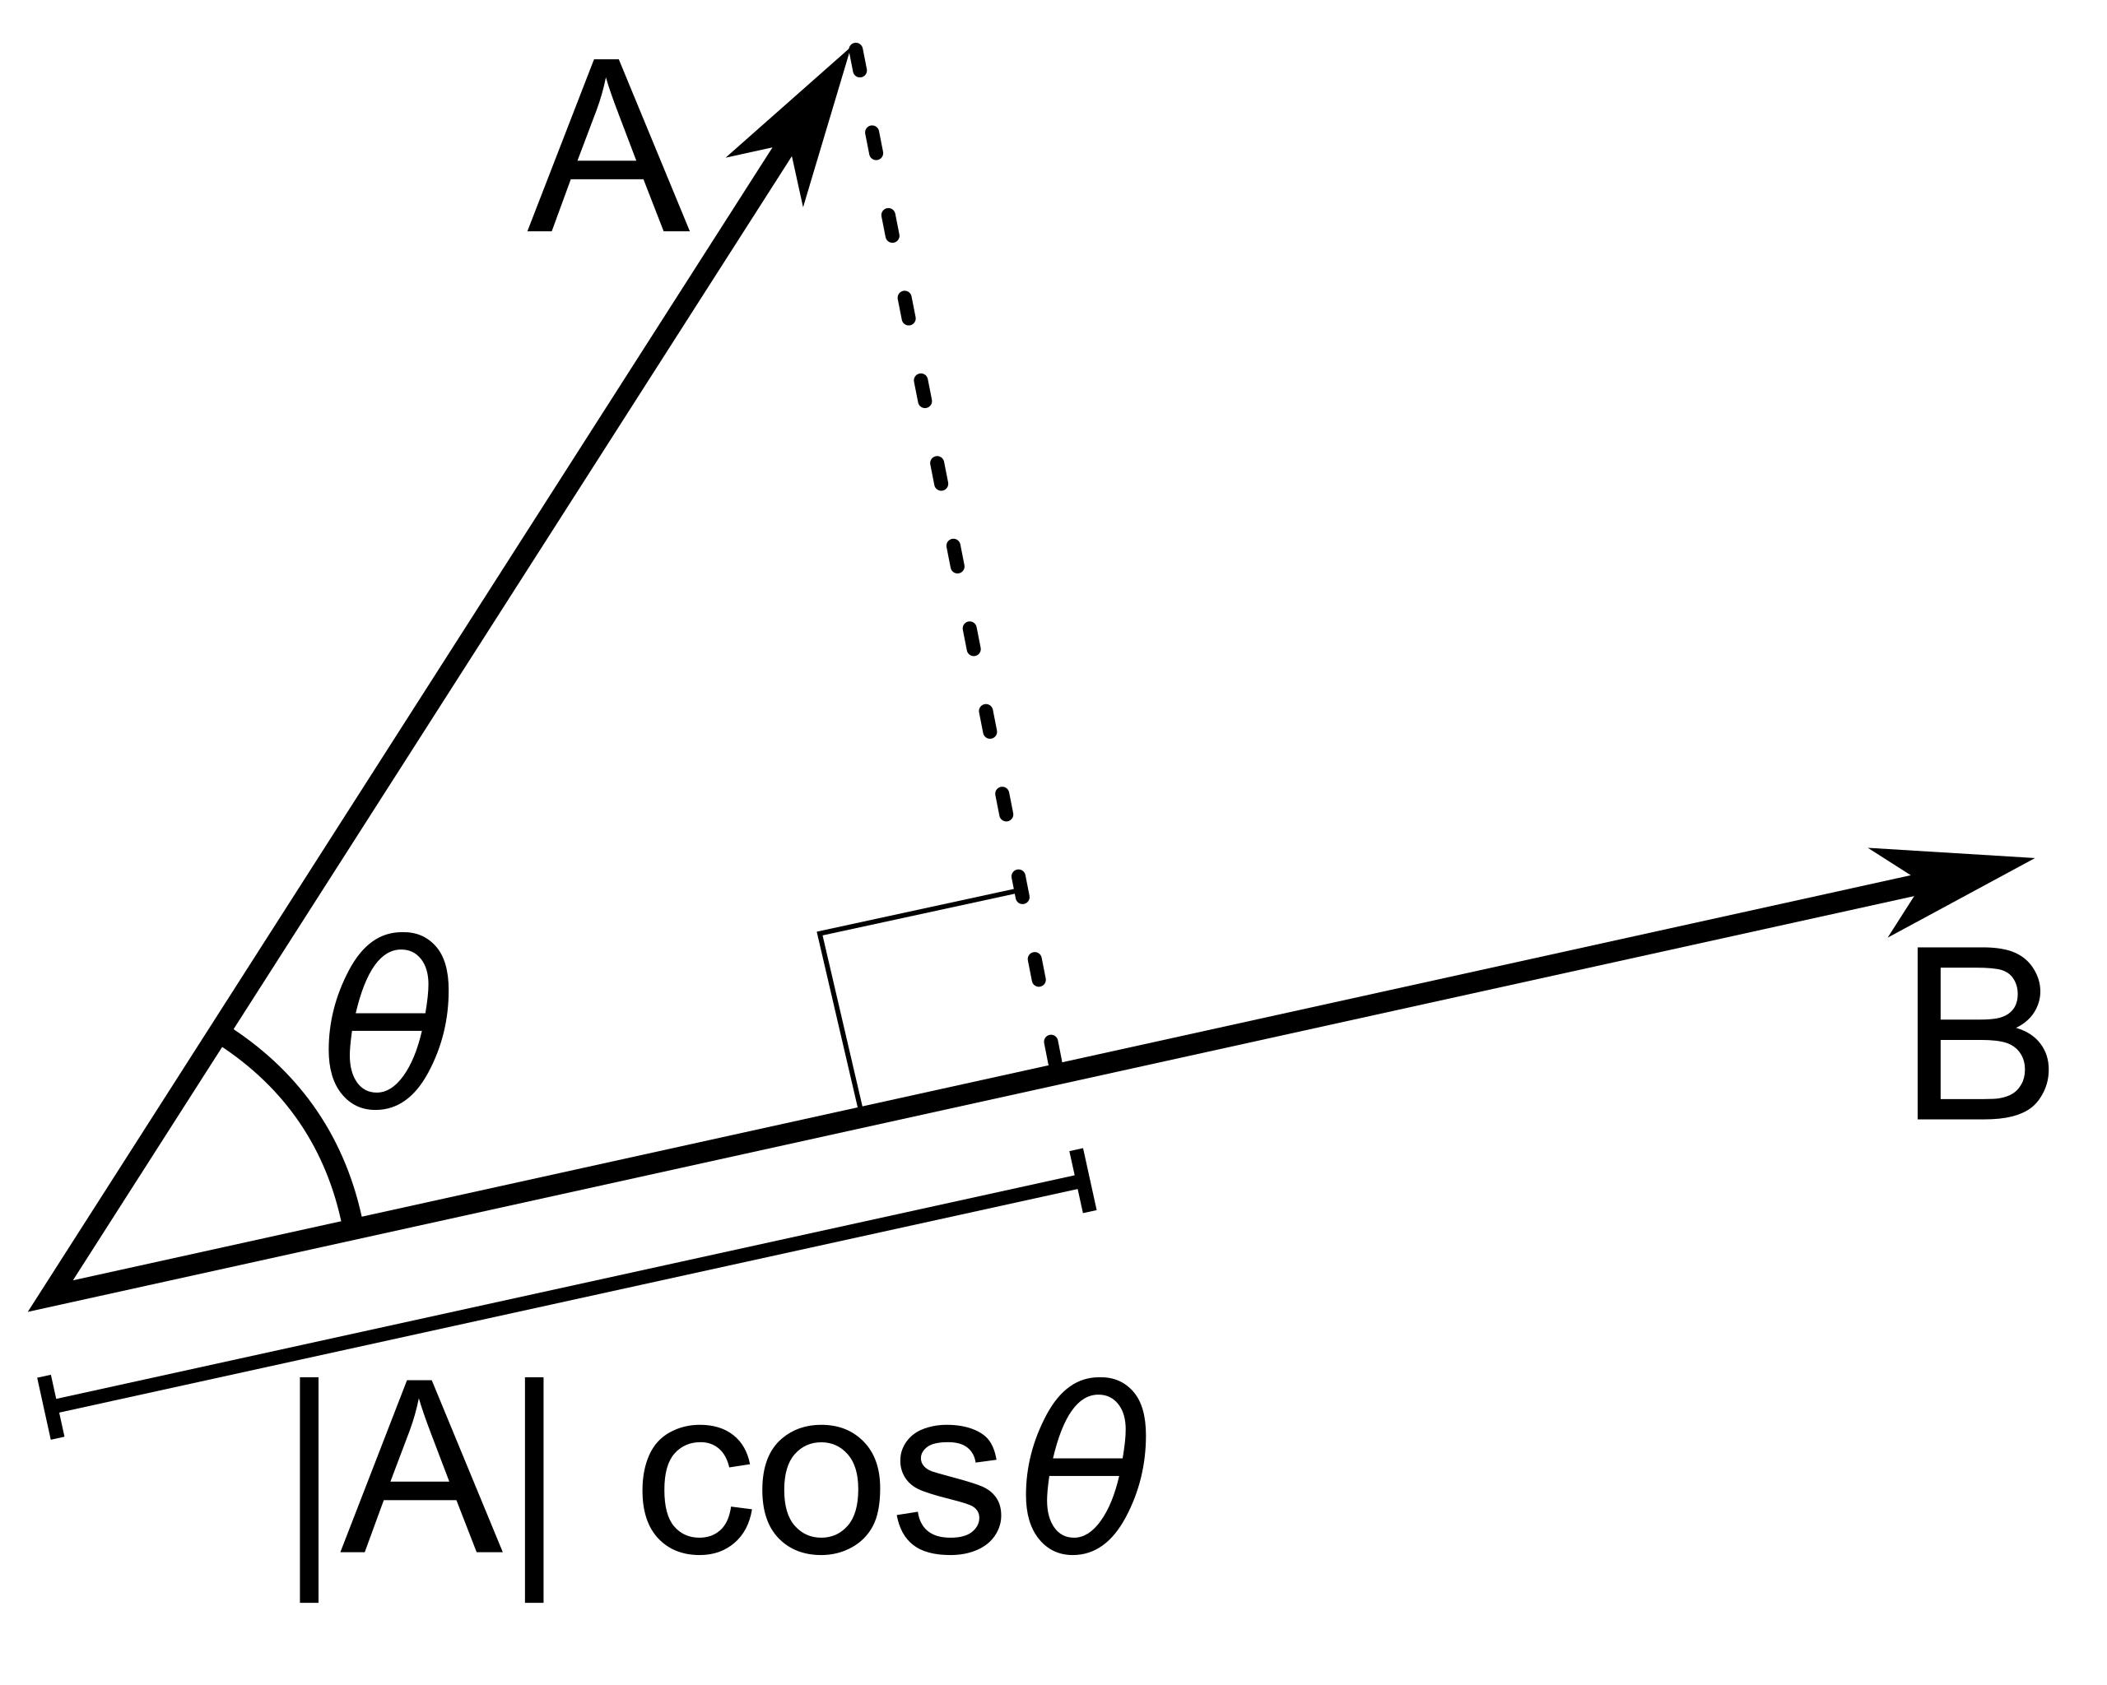
​
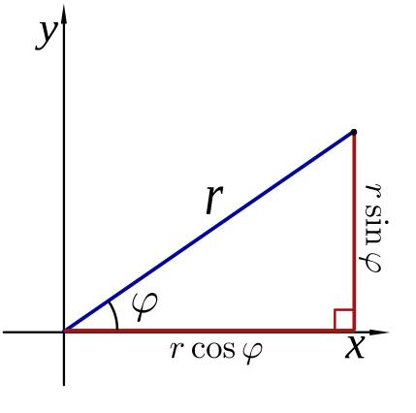
​
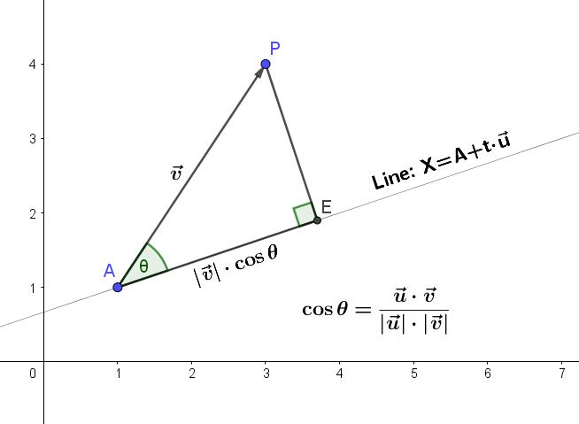
​
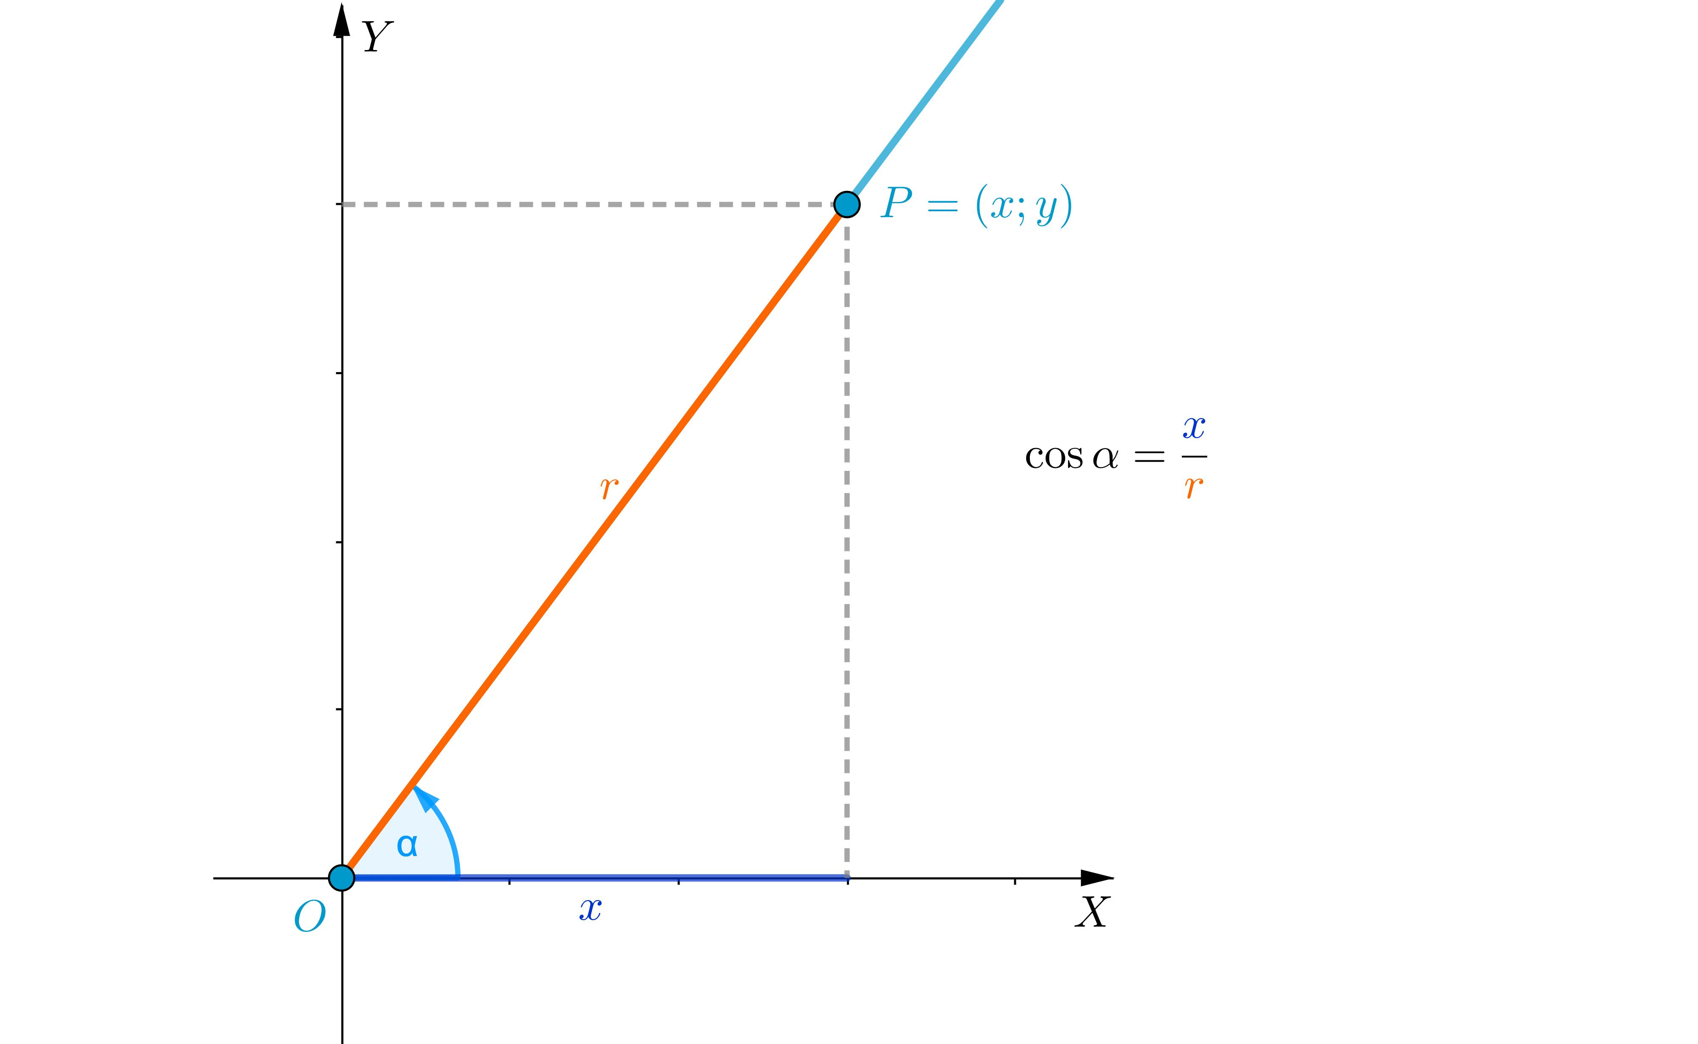
​
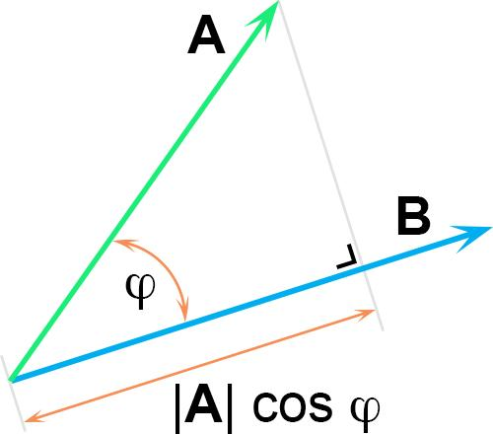
​
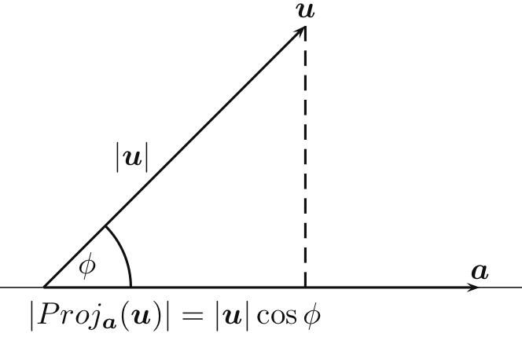

Definition
# Source: AI Source: Provided by: [Data Path: Persons Table -> ID Column: 1, Name_En Column: Motasem Essam] -> From: [ChatGPT] on [7/25/2026]
Projection and Trigonometry describes the relationship between the projection of a geometric segment and the trigonometric ratios, especially the cosine of the angle between the segment and the target line.
When a segment is projected orthogonally onto a line, the projected length represents the component of the original segment in the direction of the target line.
For a segment of length $L$ making an angle $θ$ with the target line:
$$\boxed{L_{\text{projection}}=Lcosθ}$$
For a general angle where direction matters:
$$\boxed{L_{\text{projection}}=L|cosθ|}$$

Purpose
# Source: AI Source: Provided by: [Data Path: Persons Table -> ID Column: 1, Name_En Column: Motasem Essam] -> From: [ChatGPT] on [7/25/2026]
Projection and trigonometry are used to:
- Calculate projected lengths.
- Find unknown sides of triangles.
- Resolve a segment into components.
- Find horizontal and vertical components.
- Connect geometry with trigonometric ratios.
- Solve problems involving angles and distances.
- Analyze vectors.
- Calculate heights and distances indirectly.

Basic Configuration
# Source: AI Source: Provided by: [Data Path: Persons Table -> ID Column: 1, Name_En Column: Motasem Essam] -> From: [ChatGPT] on [7/25/2026]
Consider segment $AB$ projected orthogonally onto line $l$.
Let:
- $AB=L$ be the original segment.
- $A^{'}$ and $B^{'}$ be the projected endpoints.
- $A^{'}B^{'}$ be the projection.
- $θ$ be the angle between $AB$ and $l$.
​
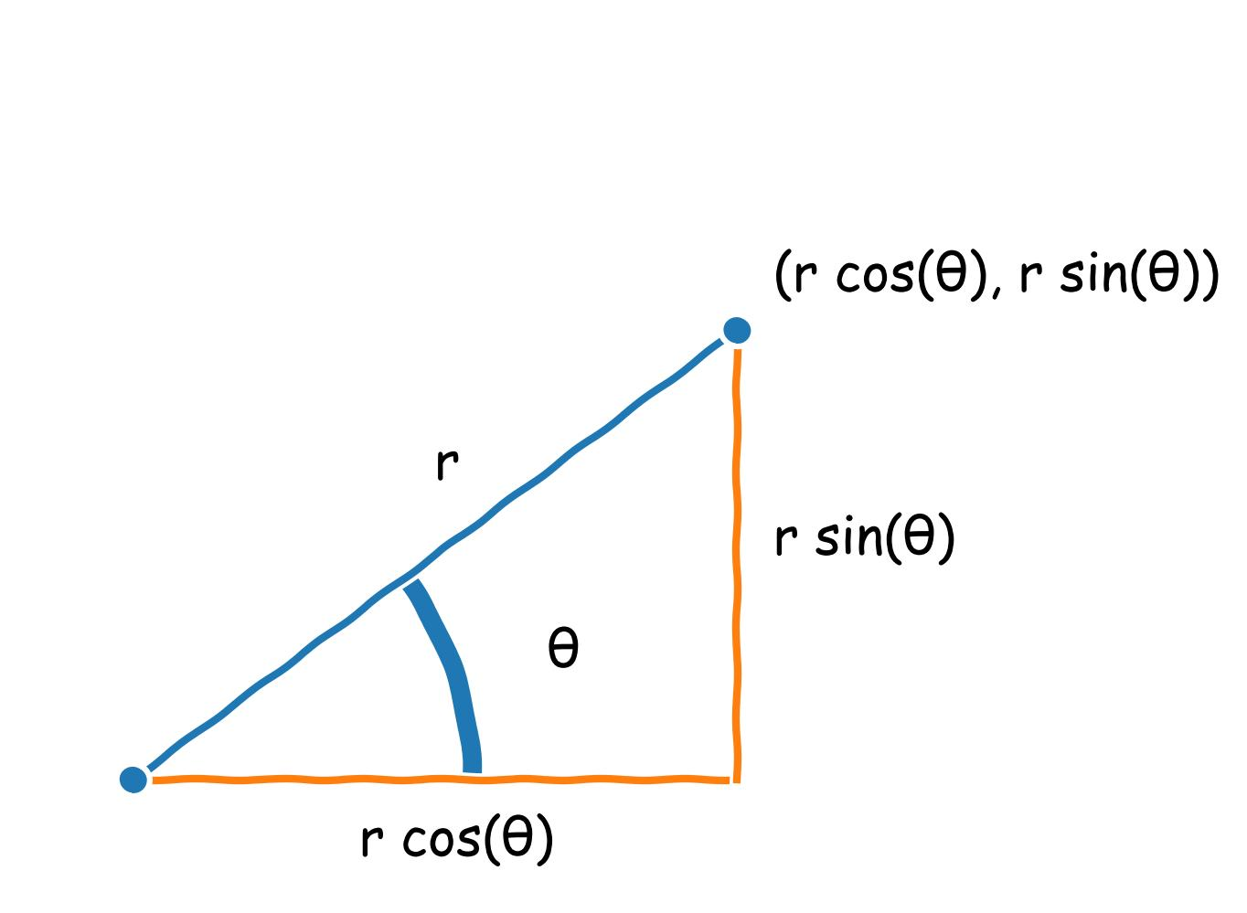
​
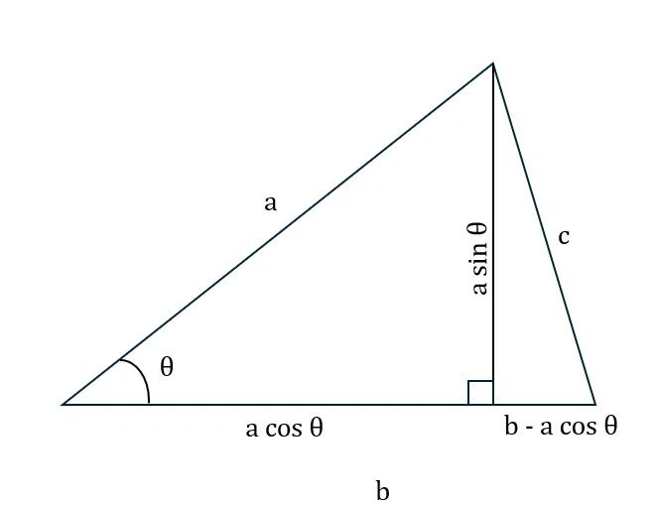
​
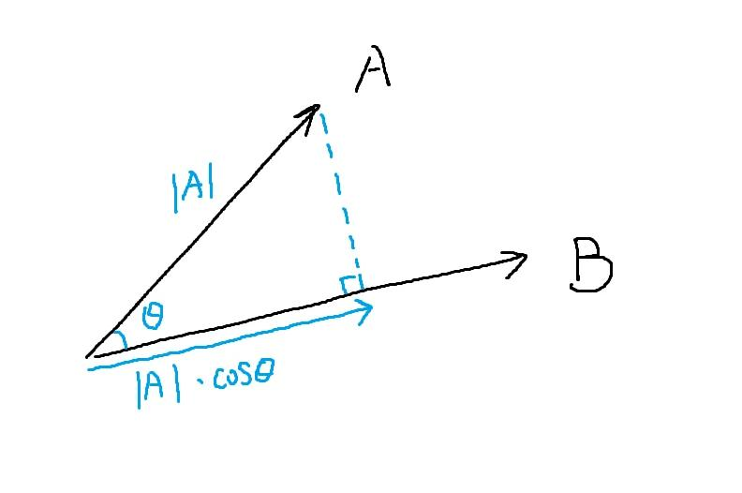
The projection creates a right triangle in which:
- $AB$ is the hypotenuse.
- $A^{'}B^{'}$ is the adjacent side to $θ$.
- The perpendicular component is the opposite side.
Therefore:
$$cosθ=\frac{A^{'}B^{'}}{AB}$$
Rearranging:
$$\boxed{A^{'}B^{'}=ABcosθ}$$

Mathematical Representation

Projection Length
# Source: AI Source: Provided by: [Data Path: Persons Table -> ID Column: 1, Name_En Column: Motasem Essam] -> From: [ChatGPT] on [7/25/2026]
For a segment of length $L$:
$$\boxed{P=Lcosθ}$$
where:
- $P$ = projected length
- $L$ = original length
- $θ$ = angle between the segment and target line
For magnitude:
$$\boxed{P=L|cosθ|}$$

Projection and the Three Basic Trigonometric Ratios
# Source: AI Source: Provided by: [Data Path: Persons Table -> ID Column: 1, Name_En Column: Motasem Essam] -> From: [ChatGPT] on [7/25/2026]
Projection is most directly related to cosine, but sine and tangent can also describe the resulting components.
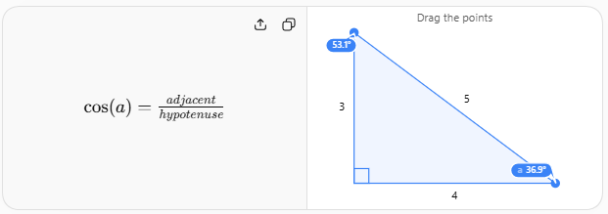

Cosine — Parallel Component
# Source: AI Source: Provided by: [Data Path: Persons Table -> ID Column: 1, Name_En Column: Motasem Essam] -> From: [ChatGPT] on [7/25/2026]
$$\boxed{cosθ=\frac{\text{adjacent}}{\text{hypotenuse}}}$$
Therefore:
$$\boxed{P=Lcosθ}$$
The cosine gives the component along the projection direction.

Sine — Perpendicular Component
# Source: AI Source: Provided by: [Data Path: Persons Table -> ID Column: 1, Name_En Column: Motasem Essam] -> From: [ChatGPT] on [7/25/2026]
The perpendicular component is:
$$\boxed{Q=Lsinθ}$$
Thus a segment can be decomposed into:
$$\boxed{Lcosθ}$$
parallel to the target line, and
$$\boxed{Lsinθ}$$
perpendicular to it.

Tangent — Relationship Between Components
# Source: AI Source: Provided by: [Data Path: Persons Table -> ID Column: 1, Name_En Column: Motasem Essam] -> From: [ChatGPT] on [7/25/2026]
The two components satisfy:
$$\boxed{tanθ=\frac{Q}{P}}$$
Therefore:
$$\boxed{tanθ=\frac{Lsinθ}{Lcosθ}}$$

Example 1 — Finding a Projection
# Source: AI Source: Provided by: [Data Path: Persons Table -> ID Column: 1, Name_En Column: Motasem Essam] -> From: [ChatGPT] on [7/25/2026]
Suppose:
$$AB=10$$
and:
$$θ={60}^{∘}$$
Then:
$$P=10cos{60}^{∘}$$
$$P=10\left(\frac{1}{2}\right)$$
$$\boxed{P=5}$$

Example 2 — Finding the Perpendicular Component
# Source: AI Source: Provided by: [Data Path: Persons Table -> ID Column: 1, Name_En Column: Motasem Essam] -> From: [ChatGPT] on [7/25/2026]
Suppose:
$$AB=10$$
and:
$$θ={30}^{∘}$$
The projection is:
$$P=10cos{30}^{∘}$$
$$P=10\left(\frac{\sqrt{3}}{2}\right)$$
$$\boxed{P=5\sqrt{3}}$$
The perpendicular component is:
$$Q=10sin{30}^{∘}$$
$$Q=10\left(\frac{1}{2}\right)$$
$$\boxed{Q=5}$$
Therefore:
$$AB^{2}=P^{2}+Q^{2}$$
$${10}^{2}=(5\sqrt{3})^{2}+5^{2}$$
$$100=75+25$$
$$100=100$$

Example 3 — Finding the Original Length
# Source: AI Source: Provided by: [Data Path: Persons Table -> ID Column: 1, Name_En Column: Motasem Essam] -> From: [ChatGPT] on [7/25/2026]
Suppose the projection is:
$$P=8$$
and:
$$θ={60}^{∘}$$
Since:
$$P=Lcosθ$$
we have:
$$8=Lcos{60}^{∘}$$
$$8=\frac{L}{2}$$
Therefore:
$$\boxed{L=16}$$

Example 4 — Finding the Angle
# Source: AI Source: Provided by: [Data Path: Persons Table -> ID Column: 1, Name_En Column: Motasem Essam] -> From: [ChatGPT] on [7/25/2026]
Suppose:
$$L=20$$
and the projection is:
$$P=10$$
Using:
$$P=Lcosθ$$
we get:
$$10=20cosθ$$
$$cosθ=\frac{1}{2}$$
Therefore:
$$\boxed{θ={60}^{∘}}$$

Projection in a Triangle
# Source: AI Source: Provided by: [Data Path: Persons Table -> ID Column: 1, Name_En Column: Motasem Essam] -> From: [ChatGPT] on [7/25/2026]
Projection and trigonometry are especially important in triangles.
Suppose triangle $ABC$ has $AB$ making an angle $B$ with $BC$, and the perpendicular from $A$ meets $BC$ at $D$.
Then $BD$ is the projection of $AB$ onto $BC$.
Therefore:
$$\boxed{BD=ABcosB}$$
Similarly, if $AC$ makes angle $C$ with $BC$, its projection onto $BC$ is:
$$\boxed{DC=ACcosC}$$
This allows a triangle to be analyzed using right-triangle trigonometry.
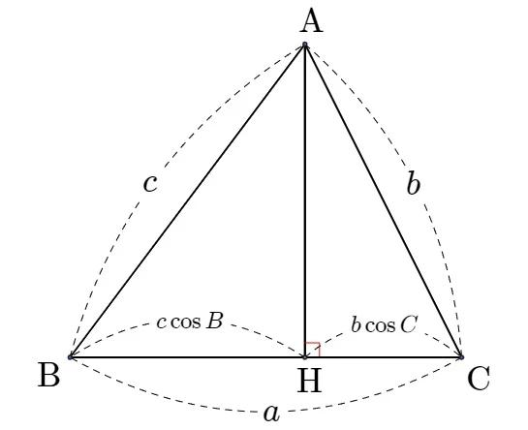
​
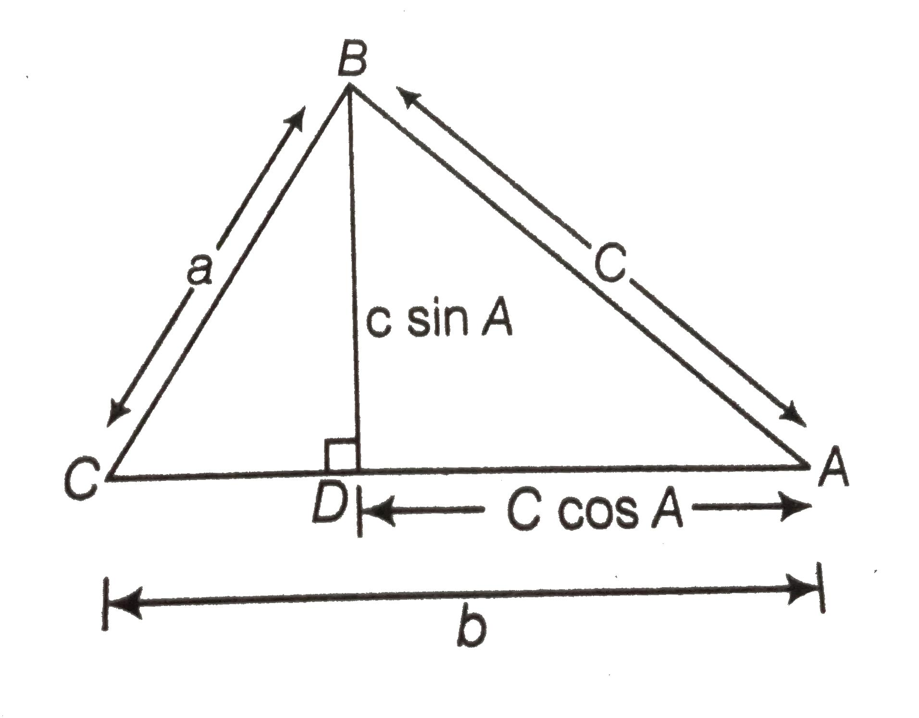​
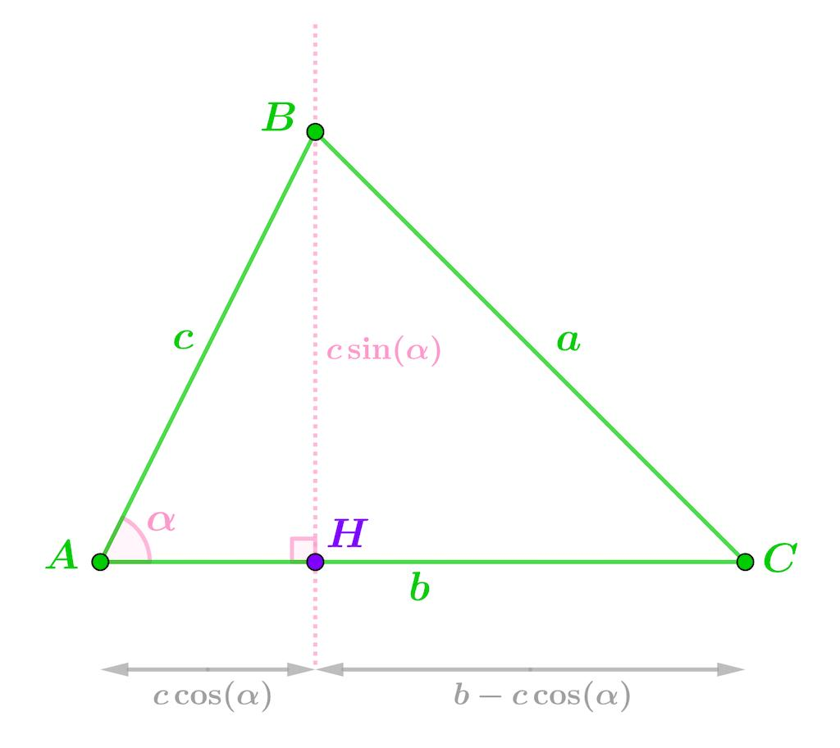
​
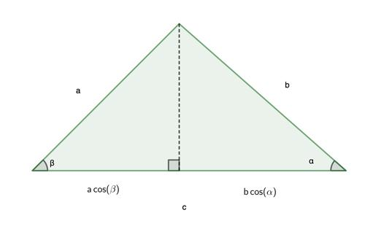

Projection and the Pythagorean Theorem
# Source: AI Source: Provided by: [Data Path: Persons Table -> ID Column: 1, Name_En Column: Motasem Essam] -> From: [ChatGPT] on [7/25/2026]
Because orthogonal projection creates a right triangle:
$$L^{2}=P^{2}+Q^{2}$$
where:
- $L$ = original segment
- $P$ = parallel projection
- $Q$ = perpendicular component
Since:
$$P=Lcosθ$$
and:
$$Q=Lsinθ$$
we obtain:
$$L^{2}=(Lcosθ)^{2}+(Lsinθ)^{2}$$
$$L^{2}=L^{2}\cos^{2}θ+L^{2}\sin^{2}θ$$
Dividing by $L^{2}$:
$$\boxed{\sin^{2}θ+\cos^{2}θ=1}$$
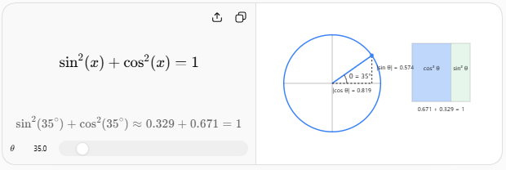
Thus, orthogonal projection provides a geometric interpretation of the fundamental Pythagorean trigonometric identity.

Special Cases
# Source: AI Source: Provided by: [Data Path: Persons Table -> ID Column: 1, Name_En Column: Motasem Essam] -> From: [ChatGPT] on [7/25/2026]
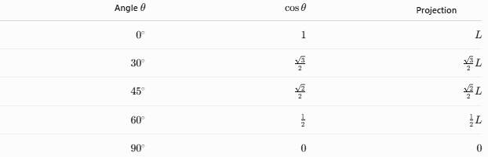
Angle $θ$ | $cosθ$​ | Projection
$0^{∘}$​ | $1$​ | $L$​
${30}^{∘}$​ | $\frac{\sqrt{3}}{2}$​ | $\frac{\sqrt{3}}{2}L$​
${45}^{∘}$​ | $\frac{\sqrt{2}}{2}$​ | $\frac{\sqrt{2}}{2}L$​
${60}^{∘}$​ | $\frac{1}{2}$​ | $\frac{1}{2}L$​
${90}^{∘}$​ | $0$​ | $0$​

Important interpretations
# Source: AI Source: Provided by: [Data Path: Persons Table -> ID Column: 1, Name_En Column: Motasem Essam] -> From: [ChatGPT] on [7/25/2026]
At $0^{∘}$:
The segment is parallel to the target:
$$P=L$$
At ${90}^{∘}$:
The segment is perpendicular to the target:
$$P=0$$
So the entire segment collapses to one projection point.

Projection and Vectors
# Source: AI Source: Provided by: [Data Path: Persons Table -> ID Column: 1, Name_En Column: Motasem Essam] -> From: [ChatGPT] on [7/25/2026]
For a vector $\vec{v}$ projected onto a unit vector $\hat{u}$:
$$\boxed{{proj}_{\hat{u}}\vec{v}=(\vec{v}⋅\hat{u})\hat{u}}$$
The scalar component is:
$$\boxed{\vec{v}⋅\hat{u}}$$
Since:
$$\vec{v}⋅\hat{u}=∥\vec{v}∥cosθ$$
we again obtain:
$$\boxed{P=Lcosθ}$$
Therefore, trigonometric projection and vector projection are two mathematical descriptions of the same geometric idea.

Projection and Horizontal/Vertical Components
# Source: AI Source: Provided by: [Data Path: Persons Table -> ID Column: 1, Name_En Column: Motasem Essam] -> From: [ChatGPT] on [7/25/2026]
A segment or vector of magnitude $L$ at angle $θ$ from the positive $x$-axis can be divided into:

Horizontal component
# Source: AI Source: Provided by: [Data Path: Persons Table -> ID Column: 1, Name_En Column: Motasem Essam] -> From: [ChatGPT] on [7/25/2026]
$$\boxed{x=Lcosθ}$$

Vertical component
# Source: AI Source: Provided by: [Data Path: Persons Table -> ID Column: 1, Name_En Column: Motasem Essam] -> From: [ChatGPT] on [7/25/2026]
$$\boxed{y=Lsinθ}$$
Thus:
$$\boxed{\vec{L}=(Lcosθ, Lsinθ)}$$
This is one of the most important applications of projection in coordinate geometry and physics.

Properties
# Source: AI Source: Provided by: [Data Path: Persons Table -> ID Column: 1, Name_En Column: Motasem Essam] -> From: [ChatGPT] on [7/25/2026]
- Projection length depends on the angle between the segment and target.
- Cosine determines the component parallel to the target.
- Sine determines the perpendicular component.
- Projection cannot exceed the original length.
- A parallel segment has maximum projection.
- A perpendicular segment has zero projection.
- Orthogonal projection creates a right triangle.
- Projection connects geometry with trigonometry.
- Vector projection uses the dot product.
- Projection is fundamental to resolving vectors into components.

Common Mistakes

1. Using sine for the parallel projection
# Source: AI Source: Provided by: [Data Path: Persons Table -> ID Column: 1, Name_En Column: Motasem Essam] -> From: [ChatGPT] on [7/25/2026]
For the component along the target:
$$\boxed{P=Lcosθ}$$
not $Lsinθ$.

2. Measuring the wrong angle
# Source: AI Source: Provided by: [Data Path: Persons Table -> ID Column: 1, Name_En Column: Motasem Essam] -> From: [ChatGPT] on [7/25/2026]
The angle must be the angle between the original segment and the target direction.

3. Confusing projection with the original segment
# Source: AI Source: Provided by: [Data Path: Persons Table -> ID Column: 1, Name_En Column: Motasem Essam] -> From: [ChatGPT] on [7/25/2026]
Generally:
$$P<L$$
unless the segment is parallel to the target.

4. Forgetting the perpendicular component
# Source: AI Source: Provided by: [Data Path: Persons Table -> ID Column: 1, Name_En Column: Motasem Essam] -> From: [ChatGPT] on [7/25/2026]
A segment can be decomposed into two perpendicular components:
$$Lcosθ$$
and:
$$Lsinθ$$

Applications
# Source: AI Source: Provided by: [Data Path: Persons Table -> ID Column: 1, Name_En Column: Motasem Essam] -> From: [ChatGPT] on [7/25/2026]
Projection and trigonometry are used in:
- Triangle geometry
- Right-triangle calculations
- Coordinate geometry
- Vector mathematics
- Physics
- Engineering
- Navigation
- Computer graphics
- Robotics
- Surveying
- Mechanics
For example, a force acting at an angle can be projected onto the horizontal and vertical directions:
$$F_{x}=Fcosθ$$
$$F_{y}=Fsinθ$$

Advantages
# Source: AI Source: Provided by: [Data Path: Persons Table -> ID Column: 1, Name_En Column: Motasem Essam] -> From: [ChatGPT] on [7/25/2026]
- Converts geometric problems into trigonometric problems.
- Makes complicated figures easier to analyze.
- Provides a direct way to calculate components.
- Connects triangles, vectors, and coordinates.
- Useful for both 2D and 3D mathematics.
- Provides geometric meaning to sine and cosine.

Limitations
# Source: AI Source: Provided by: [Data Path: Persons Table -> ID Column: 1, Name_En Column: Motasem Essam] -> From: [ChatGPT] on [7/25/2026]
- Requires careful identification of the correct angle.
- Orthogonal projection does not generally preserve lengths.
- Projection alone does not provide directional information unless signs are included.
- For complicated 3D projections, vector methods may be necessary.
- Using $L|cosθ|$ gives magnitude but loses the direction/sign of the component.

Comparison with Related Concepts
# Source: AI Source: Provided by: [Data Path: Persons Table -> ID Column: 1, Name_En Column: Motasem Essam] -> From: [ChatGPT] on [7/25/2026]
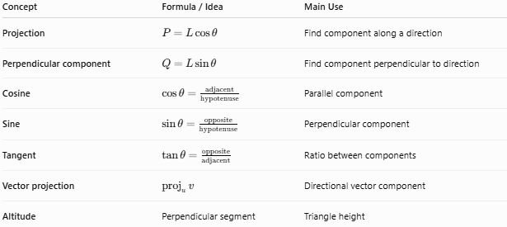
Concept | Formula / Idea | Main Use
Projection | $P=Lcosθ$​ | Find component along a direction
Perpendicular component | $Q=Lsinθ$​ | Find component perpendicular to direction
Cosine | $cosθ=\frac{\text{adjacent}}{\text{hypotenuse}}$​ | Parallel component
Sine | $sinθ=\frac{\text{opposite}}{\text{hypotenuse}}$​ | Perpendicular component
Tangent | $tanθ=\frac{\text{opposite}}{\text{adjacent}}$​ | Ratio between components
Vector projection | ${proj}_{u}v$​ | Directional vector component
Altitude | Perpendicular segment | Triangle height

Key Points
# Source: AI Source: Provided by: [Data Path: Persons Table -> ID Column: 1, Name_En Column: Motasem Essam] -> From: [ChatGPT] on [7/25/2026]
- Projection and trigonometry are directly connected.
- The main projection formula is:
$$\boxed{P=Lcosθ}$$
- The perpendicular component is:
$$\boxed{Q=Lsinθ}$$
- Together:
$$\boxed{L^{2}=P^{2}+Q^{2}}$$
- The projection is maximum when $θ=0^{∘}$.
- The projection is zero when $θ={90}^{∘}$.
- Cosine describes the component along the target direction.
- Sine describes the component perpendicular to the target direction.
- Vector projection is the vector form of the same concept.

Conclusion
# Source: AI Source: Provided by: [Data Path: Persons Table -> ID Column: 1, Name_En Column: Motasem Essam] -> From: [ChatGPT] on [7/25/2026]
Projection and Trigonometry establishes the fundamental connection between geometric projection and trigonometric ratios. When a segment is projected onto a line, its projected length is determined by the cosine of the angle between them:
$$\boxed{\text{Projection}=\text{Original Length}×cos(\text{Angle})}$$
This makes projection a fundamental bridge between geometry, trigonometry, vectors, coordinate geometry, and physics.

